**PROJECT PROPOSAL (3-SEVEN TETRIS by .DUEL)**

1. **Abstract**

3-SEVEN TETRIS is a game that combines the game concept of classic “Tetris” with “Dr. Mario” with a little basic arithmetic logic.

The game rules are simple,:

* In terms on getting the block to dissolve, players need to line up three blocks in either vertically, horizontally, or diagonally with to get a sum of the number “7” or three block with the number “7”.
* Once the block reached and touched the top of the space provided, the game will be forfeited.
* High score achieved by the total sum of the block dissolved and will be recorded individually to indicate the best player.

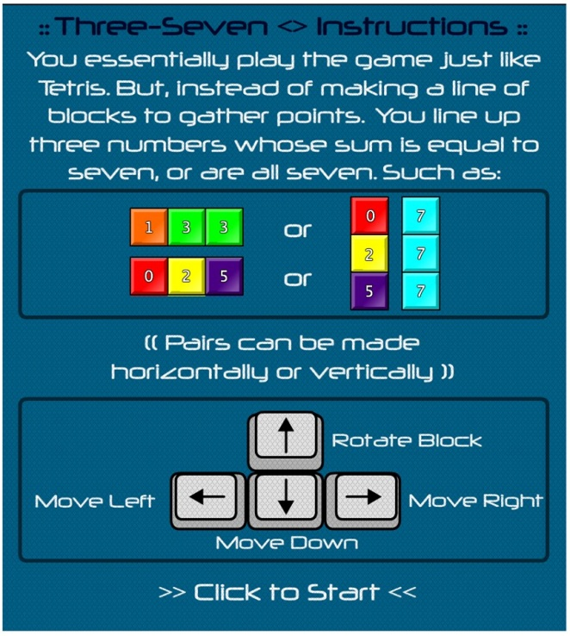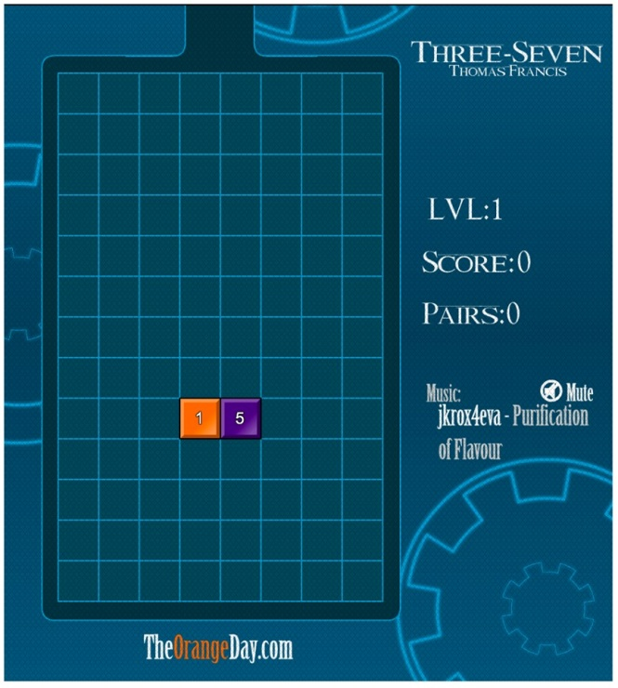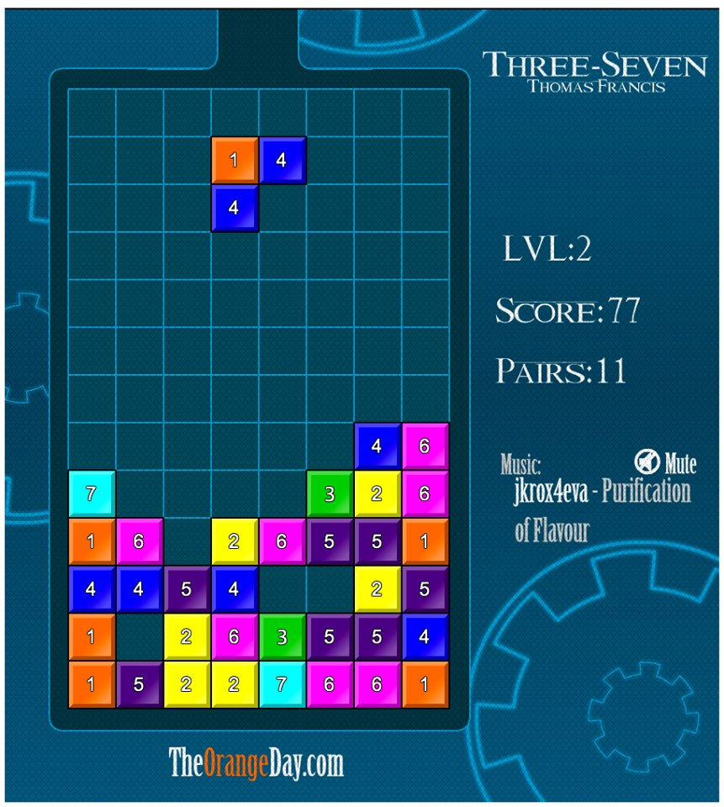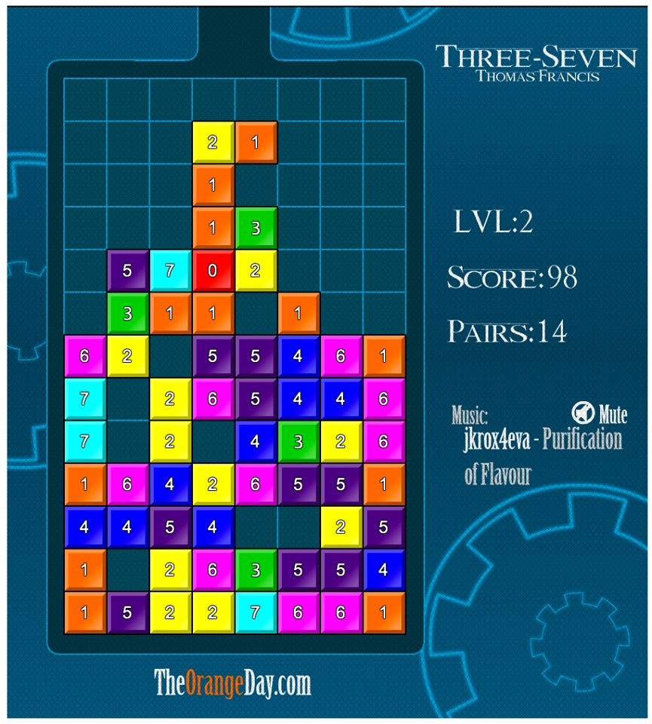

**2. Background study**

**Tetris**

Tetris was created by Alexey Pajitnov at year 1984 in Moscow Academy of Science’s Computer Center. The Tetris name was came from the greek numerical prefix for four which means “tetra” and Alexey’s favorite sport which is “tennis”.

Earliest version of Tetris was name as “Tetris: Soviet Challenge”, this version was like using a picture as its background and there are only 4 to 5 colours which is not pleasing at all. Tetris has been improved from year to year that until today it has more than hundred versions.

Tetris can play in many types of devices such smartphone, Gameboy, tablet, PC and others. This game contains few shapes and these shapes are used to fill in an empty field, it will automatic dissolved when any rows were fully filled.

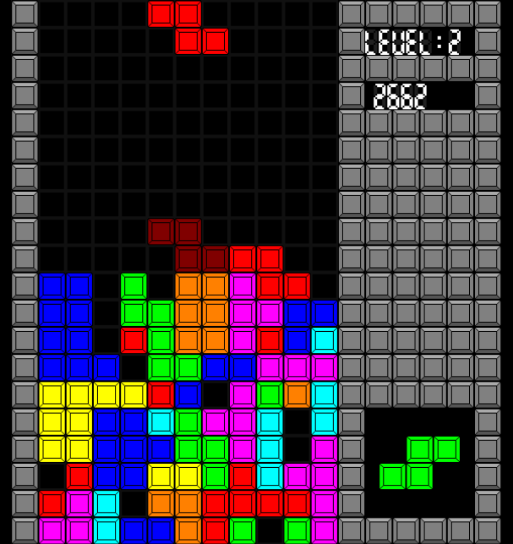

Picture 1. Sample of Tetris

**Dr.Mario**

Dr. Mario was designed by Gunpei Yokoi and later produced by Takahiro Harada at 27 July, 1990. The first version was published by Nintendo. The game concept is almost same with Tetris, but it is about a character name as Mario and he is a doctor which in charge in exterminating deadly virus. In this falling block puzzle game, players have to dissolve the viruses using coloured capsules by matching the same colour of the capsules.

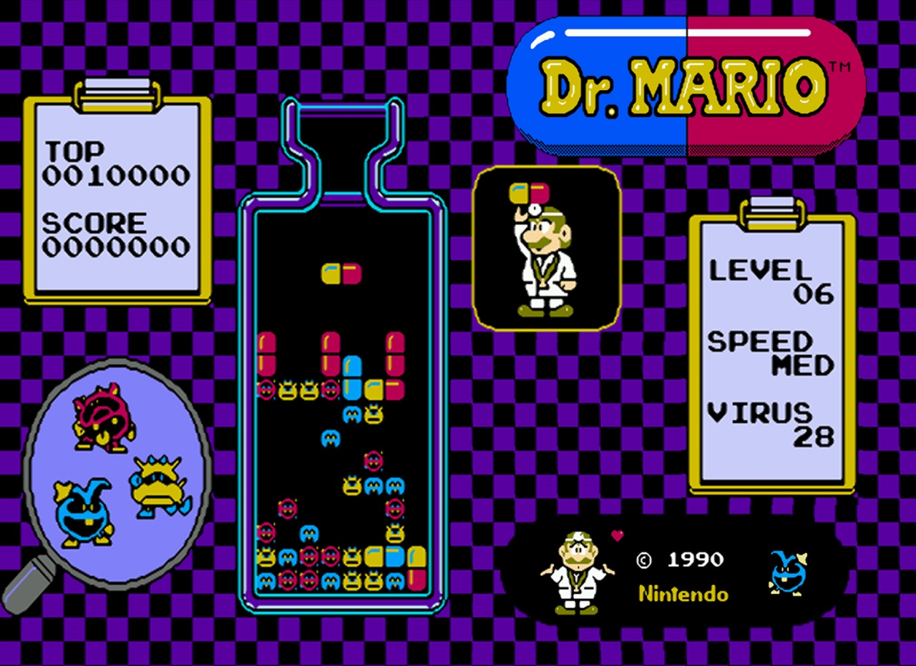

Picture 2. Sample of Dr. Mario

**3. Problem statement**

**Current problem:**

How to build a good user interface? User interface is build either in horizontal view or vertical view.

* Customers have to feel comfort with the interface so that the game is easy to play for them and strike for a high score.
* Horizontal and vertical view have their own good interface as the control button and the playing field (a rectangular vertical shaft, called the "well" or "matrix") are arranged differently in different view.

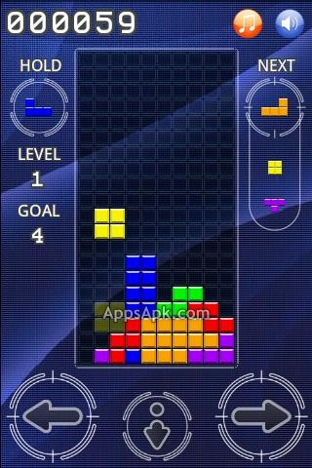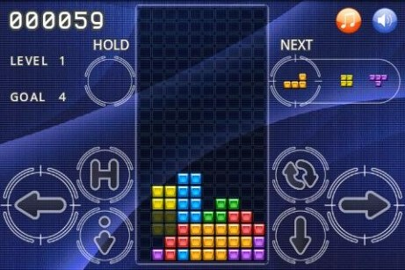

**Future problem:**

How to attract more people to play on this game?

* The more people involved in this game, the more confident game developers upgrade the game to make it more interesting.
* People would feel boring and mad when the game is full of bugs and have a bad interface.

**Problem statement:**

How do game developers build a good user interface and attract more people to involved and play on this game?

**4. Objectives**

* The objective of this game is to test players' collaboration between reflex and basic arithmetic skills.
* The game must have a good interface which contains control buttons, playing field, score board.
* Single mode: which is the basic mode for players to play the game in an offline mode and exceed personal scores.
* Multiplayer mode: which is an extra mode for players to play the game either with their friends or with other players over the world.
* High popularity and reputation: Popularity of the game will be increased once players start to rate the game based on stars.

**5. Scope**

|  |  |
| --- | --- |
| Scope | Description |
| Deliverables | * Make a math tetris for android user |
| Critical Success Factors | * To test players mathematical skills * To test players decision making * To let players have the chance to duel the game with their friends |
| Critical Success Measures | * Tetris block should dissolve when sum of three blocks is 7 or three blocks of ‘7’ are lines together |
| Constraints | * Only available for Android user |
| Assumptions | * The whole project would be done within 3 months * No cost but only time consume in this project * All hardware and software are usable when develop the game |

**6. Task Allocation**

|  |  |  |
| --- | --- | --- |
| Name | Role | Task/Description |
| LIM PEI YONG | 1. Project Manager | * Allocate project role to team members * Assign task to team members according to their role * Conduct brainstorming and meeting sessions with the team |
| 1. Planning Manager | * Plan meeting time among team members * Plan project development process * Plan development resources (e.g. API,SDK) |
| WILLIAM NGU WEE HONG | 1. Test Manager | * Test the game developed by team members |
| 1. Process Manager | * Execute development processes as planned * Design game rule * Provide development resources (e.g. API, SDK) * Execute process documentation |
| ABDUL RAHIM BIN MOHAMAD | 1. Customer Interface Manager | * Design game interface * Design player database |
| 1. Implementation Manager | * Implement the game rule/logic with the game interface |
| LIM CHONG FATT | 1. Quality Manager | * Determine the game quality |
| HOE YOU TIEN | 1. Support Manager | * Provide support on development processes |

**7. Team Goal**

Team goal of this project is to create “3-SEVEN TETRIS” game successfully. Duration of time to complete this project is 3 months.

**8. Team Contribution**

|  |  |  |  |  |  |
| --- | --- | --- | --- | --- | --- |
| Task \ Team members | A | B | C | D | E |
| Team Meeting | 5 | 5 | 5 | 5 | 5 |
| Research | 3 | 3 | 2 | 1 | 1 |
| Documentation | 2 | 2 | 2 | 1 | 0 |
| Testing | 1 | 1 | 2 | 4 | 5 |
| Total Hours | 11 | 11 | 11 | 11 | 11 |

|  |  |  |
| --- | --- | --- |
| Member’s Name | Student ID | Signature |
| A. LIM PEI YONG | 36732 |  |
| B. WILLIAM NGU WEE HONG | 39322 |  |
| C. ABDUL RAHIM BIN MOHAMAD | 35282 |  |
| D. LIM CHONG FATT | 36712 |  |
| E. HOE YOU TIEN | 36249 |  |

**9. Expected Result**

The expected result will be that the game created will let players to experience a different kind of game based on the mathematical skills either in single mode or in multiplayer mode.

**10. Project Planning**

|  |  |  |  |  |  |  |  |  |  |  |  |  |  |  |  |  |  |  |  |  |  |  |  |  |  |  |  |  |  |  |  |  |  |
| --- | --- | --- | --- | --- | --- | --- | --- | --- | --- | --- | --- | --- | --- | --- | --- | --- | --- | --- | --- | --- | --- | --- | --- | --- | --- | --- | --- | --- | --- | --- | --- | --- | --- |
| WEEKS/ACTIVITY | 3 | | 4 | | 5 | 6 | | 7 | | 8 | | | 9 | | | 10 | | | 11 | | | 12 | | | 13 | | | 14 | | | 15 | | |
| A |  | |  | |  |  | |  | |  | | |  | | |  | | |  | | |  | | |  | | |  | | |  | | |
| B |  |  | | |  | |  | |  | |  | | |  | | |  | | |  | | |  | | |  | | |  | | |  | |
| C |  | |  |  | | | | | | | |  | | |  | | |  | | |  | | |  | | |  | | |  | | |  |
| D |  | |  | |  |  | |  | |  | | | | | | | | |  | | |  | | |  | | |  | | |  | | |
| E |  | |  | |  |  | |  | |  | | | | | | | | |  | | |  | | |  | | |  | | |  | | |
| F |  | |  | |  |  | |  | |  | | | | | | | | |  | | |  | | |  | | |  | | |  | | |
| G |  | |  | |  |  | |  | |  | | |  | | |  | | |  | | | | | | |  | | |  | | |  | |
| H |  | |  | |  |  | |  | |  | | |  | | |  | | |  | | |  | | |  | | | | | | |  | |
| I |  | |  | |  |  | |  | |  | | |  | | |  | | |  | | |  | | |  | | |  | | |  | | |

|  |  |
| --- | --- |
| TASK | DESCRIPTION |
| A | Drafting out what to do for the project alongside with doing the project proposal. |
| B | Finalizing the project proposal. Adding details according to the lecturer’s needs. |
| C | Each team members need to master the platform agreed on. Meetings with members are done 2-3 times a week to share what each of us has learns. |
| D | A team member are given the task to find sources of code, meeting the lecturer, and other considered unrelated task with the coding needed to be done. |
| E | Two members are assigned to build the Graphical User Interface and design the environment for the project. |
| F | Two members are assigned to focus on the making of the project. Meaning, if there are graphic movement, what a button do when pressed, or etc. |
| G | Synchronizing both, the interface and main part of the project. Synchronization needed to be done until there are no more errors in the project. |
| H | Team members do some testing on the game. All necessary tests will be done to avoid the project to crash. If there are repairs or improvements needed to be implemented, it is done right away. |
| I | Finalize the project and prepare the game to be presented to assign lecturer. |